Data source for real-world data:

Vaccination coverage:
https://ourworldindata.org/covid-vaccinations

COVID-19 infection:
https://www.cdc.gov/nrevss/php/dashboard/index.html

https://data.cdc.gov/Laboratory-Surveillance/Percent-Positivity-of-COVID-19-Nucleic-Acid-Amplif/gvsb-yw6g

Rationale to multiply the daily risk by 10 to account for under-reporting
“The median estimates for the ratios of estimated cases to reported cases from March 1 to April 4, 2020 for the adjusted div-Hist method is 18 (with a 90% interval from 1 to 101), for adjusted div-Vir is 21 (2, 67), for adjusted COVID-Scaling is 17 (3, 76), for adjusted mMAP is 11 (4, 20), and for GLEAM is 10 (2, 29).” https://pmc.ncbi.nlm.nih.gov/articles/PMC8241061/#sec002

Vaccine effectiveness:
https://www.nejm.org/doi/full/10.1056/NEJMc2302462

Data-generating parameters from real-world data
- Seasonality of infection risk

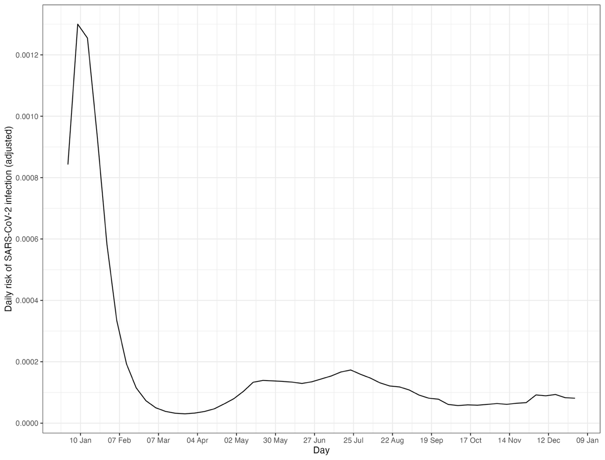

- Seasonality of vaccination
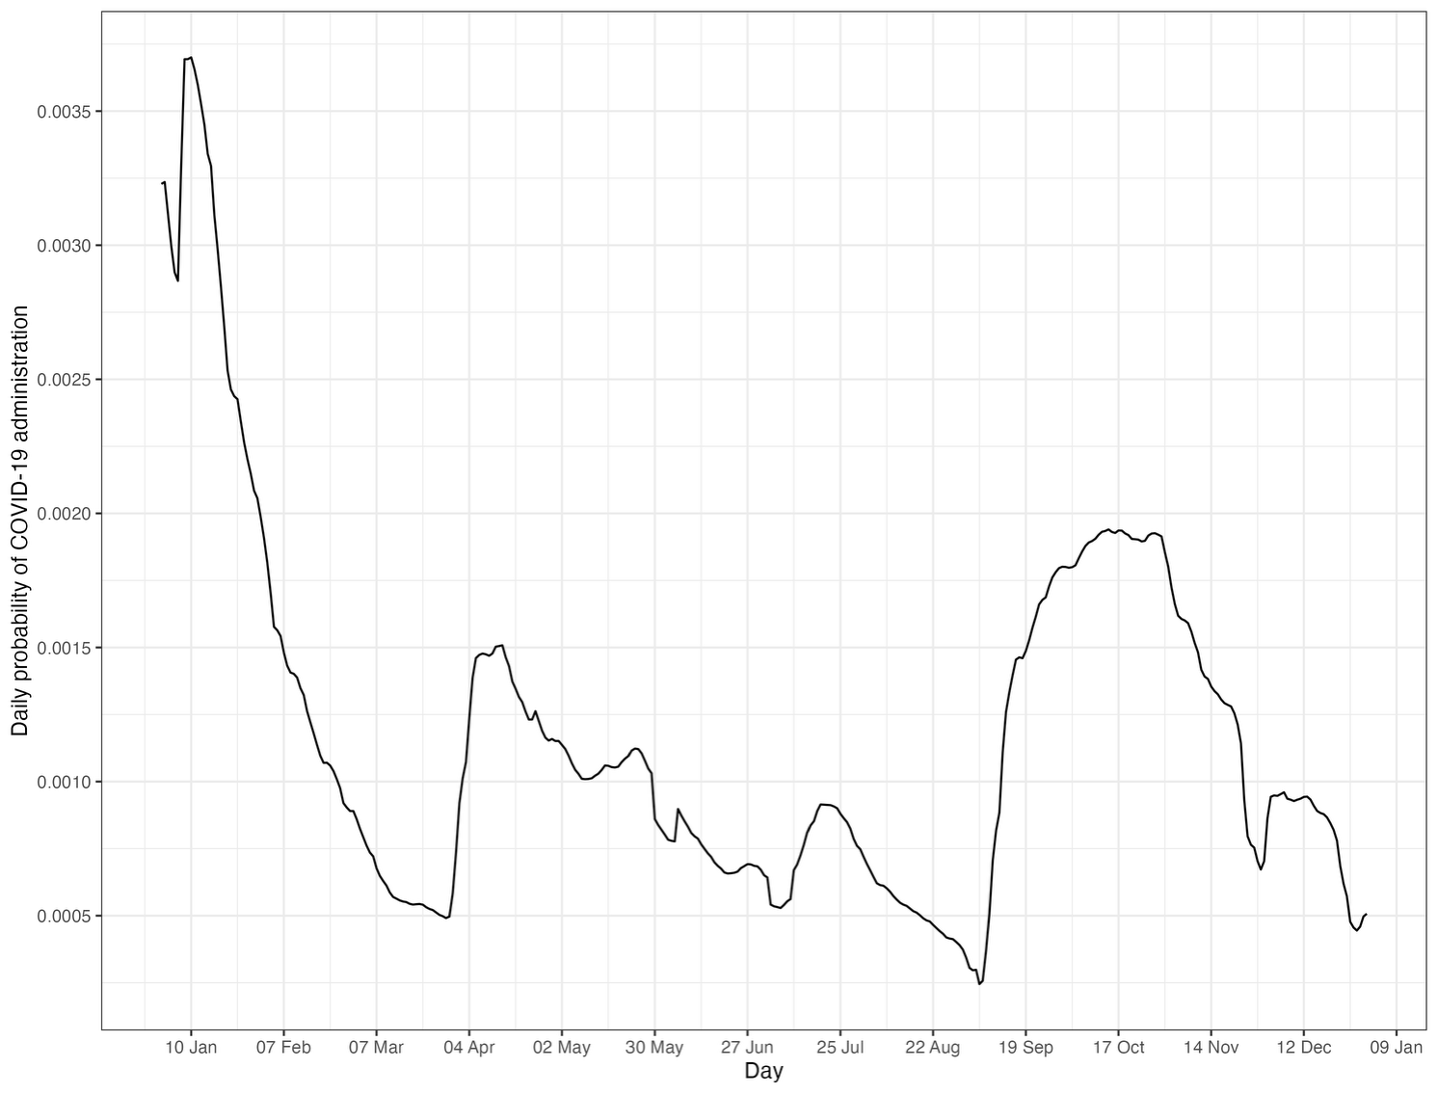

- Vaccine effectiveness
- Peaks at 67% VE on day 15

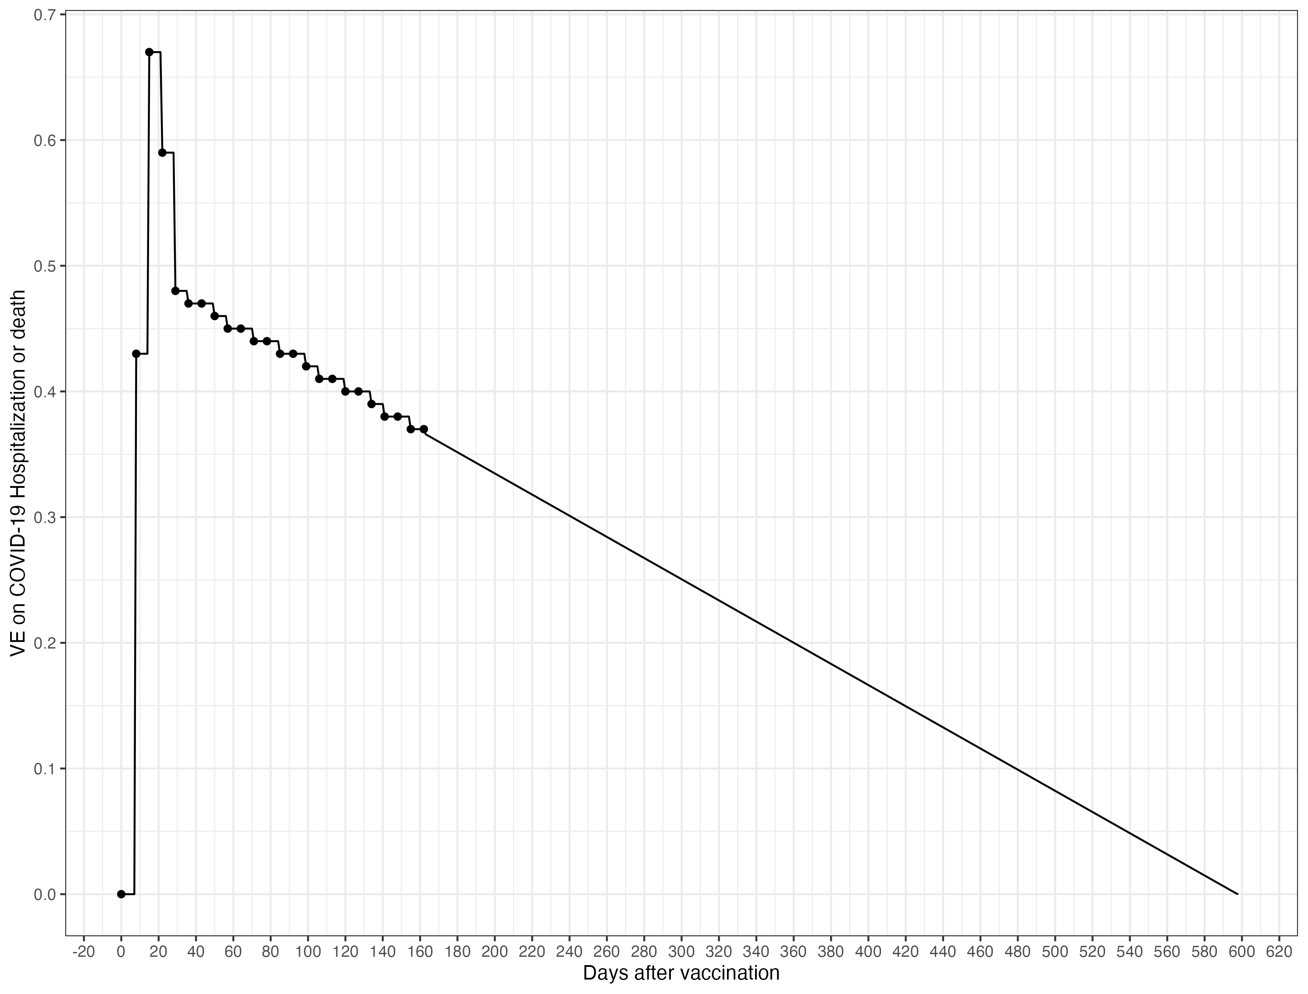
- SCCS model:
- Control: Day 0-7
- Risk period: Day 15-21 and day 15-35
- With and without adjustment for calendar time

- Include misspecification of risk/ control period?

